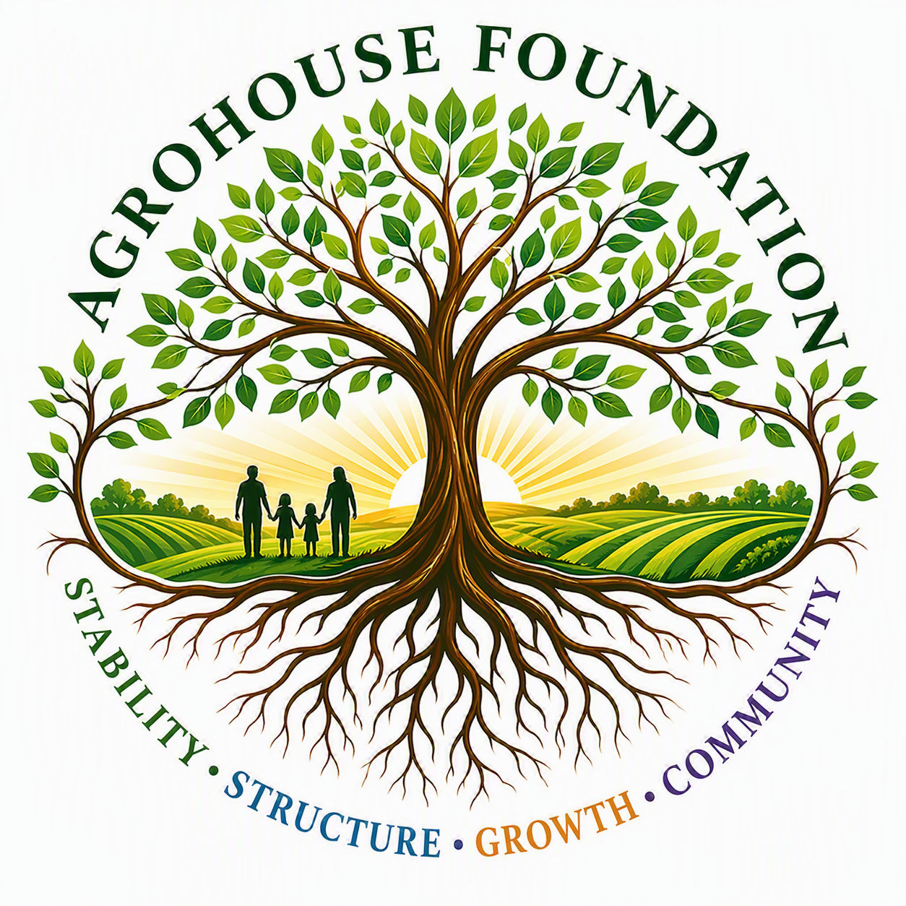
AGHF INC.
d/b/a AgroHouse Foundation
MEETING AGENDA
Board of Directors — Organizational Meeting
DISTRIBUTE AT LEAST 7 DAYS PRIOR TO MEETING
Stability • Structure • Growth • Community

Organizational Meeting of the Board of Directors
Date | Time | Location
____________________ | _______________ | ______________________________

AGENDA
- Call to Order & Roll Call
- Confirmation of Incorporation (Articles of Incorporation filed with the State of Florida)
- Adoption of Bylaws
- Election of Officers (Chairperson, Vice Chairperson, Treasurer, Secretary)
- Adoption of Governance Policies (Conflict of Interest, Whistleblower, Code of Ethics, Record Retention & Document Destruction, Donation Acceptance, Gift/In-Kind Valuation)
- Adoption of Resolutions (Banking, Founder Recognition, Compensation, EIN Filing Authorization, Website Launch Plan & Authorization)
- Founder Recognition Discussion
- Founder Compensation Discussion & Vote (disinterested Directors)
- EIN Application Authorization
- Banking Authorization & Signer Designation
- Website Launch Planning — Domain, Budget & Timeline (contingent on Sunbiz approval)
- Program 1 Status Update — Community Outreach Stabilization
- Program 2 Planning Update — Farm Infrastructure & Operations (informational only; no launch authorization)
- Community Partnership Update — First Nazarene Church of Zephyrhills
- Insurance & Compliance Review
- Next Steps & Assignments
- Schedule Next Meeting
- Adjournment

MATERIALS TO BE REVIEWED
- Draft Bylaws
- Draft Conflict of Interest Policy
- Draft Whistleblower Policy
- Draft Resolutions (Banking, Founder Recognition, Compensation, EIN)
- Master Knowledge Base (organizational reference)
Please review all attached materials prior to the meeting.

